**Digital Nurture 4.0 Java FSE**

**Week 7 ReactJS - HOL**

**Additional Mandatory Exercise (HandsOn 15)**

**Exercise 15:** Create a React App named “ticketraisingapp” which will help to raise a complaint and get it resolved.

Create a component named “ComplaintRegister” with a form containing a textbox to enter the employee name and a textarea to enter the complaint. Use “handleSubmit” event of the button to submit the complaint and generate a Reference number for further follow ups in the alert box.

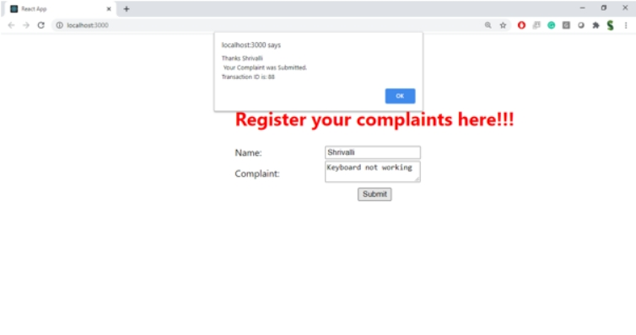**Output Expected:**

**Hint:**

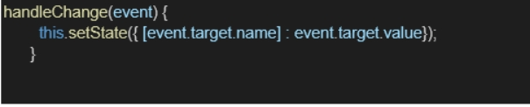

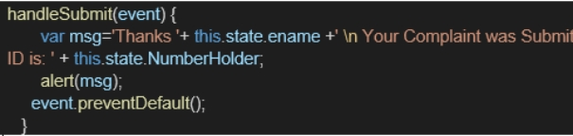

**Answer:**



**App.js:**

import React from 'react';

import ComplaintRegister from './ComplaintRegister';

function App() {

  return (

    <div className="App">

      <ComplaintRegister />

    </div>

  );

}

export default App;

**ComplaintRegister.js:**

import React, { useState } from 'react';

const ComplaintRegister = () => {

  const [name, setName] = useState('');

  const [complaint, setComplaint] = useState('');

const handleSubmit = (event) => {

    event.preventDefault();

    const transactionId = Math.floor(Math.random() * 100) + 1;

    alert(`Thanks ${name}, Your Complaint was Submitted. Transaction ID is: ${transactionId}`);

  };

  return (

    <div>

      <h1 style={{ color: 'red' }}>Register your complaints here!!!</h1>

      <form onSubmit={handleSubmit}>

        <div>

          <label>Name:</label>

          <input

            type="text"

            value={name}

            onChange={(e) => setName(e.target.value)}

          />

        </div>

        <div>

          <label>Complaint:</label>

          <textarea

            value={complaint}

            onChange={(e) => setComplaint(e.target.value)}

          />

        </div>

        <button type="submit">Submit</button>

      </form>

    </div>

  );

};

export default ComplaintRegister;

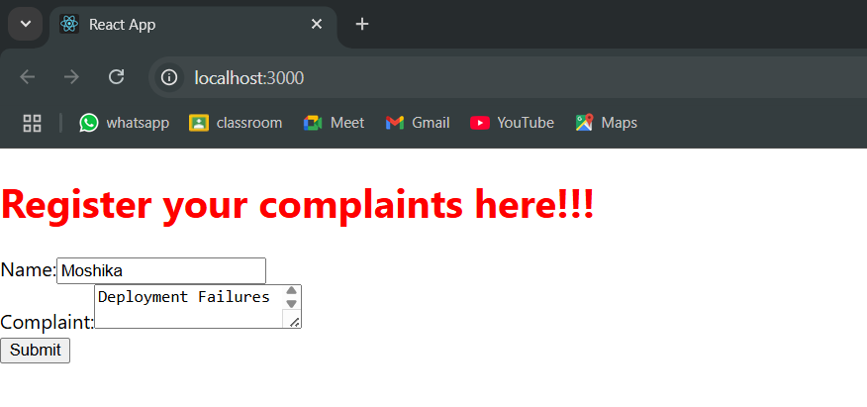**Output:**

